Professional Portfolio

This section contains my professional and business ventures, work, and history including work I have done and my updated resume.

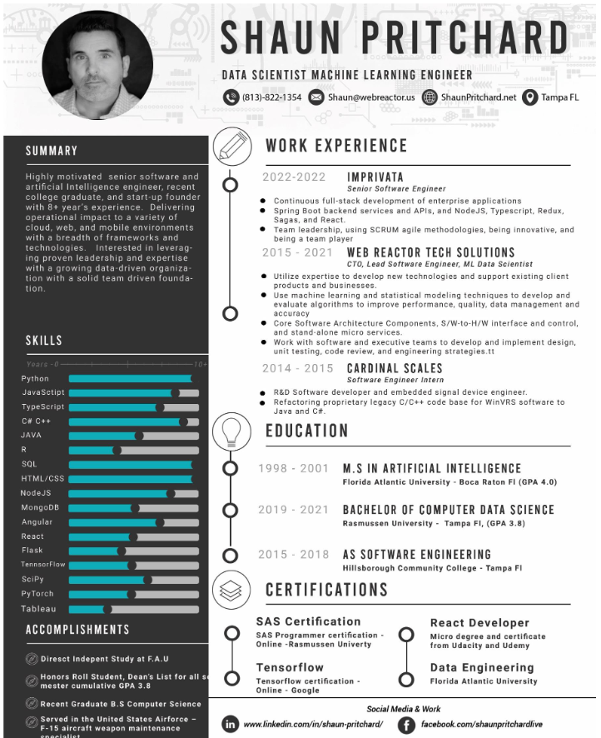

**SUMMARY**

Detailed oriented, 8+ years’ experience with a strong mathematics and computer science background. I am a result-driven senior level software engineer / AI data scientist. Since 2013. I have designed, developed, and managed user centric agile CI/CD production applications and enterprise products. I am proficient in implementing multiple technologies and programming languages such as React, Python and JAVA. For 5+ years I have implemented, researched, and studied AI, machine learning, predictive modeling, data processing, publishing independent research, and data mining algorithms to solve viable business challenges. I also have a range of skills in automating, testing, statistical models, algorithms design, and problem-solving.

**EXPERIENCE**

***Imprivata, Clearwater Fl, Senior Software Engineer - 2022-Current***

Imprivata is a leading big tech enterprise medical industry cloud-based digital identity ecosystem. As a senior software engineer, my duties were to deliver Agile CI/CD full-stack development solutions, integrate new React designs over the old JSF implementation of the Fair-Warning drug diversion platform. Among my responsibilities were building and re-engineering new frontend applications, UX/UI designs, and API’s with Node JS, React , Typescript, Redux, and Sagas. I was responsible for Integrating Storybook UI into the dev-stack. Maintained backend services, API, documentation, and bug fixes in JSF, Spring Boot, Swagger, and Spring Security. I am also responsible for introducing new technologies for SSO testing; such as KeyCloak. Developing standalone big data web scraping tools using Python. Introducing Docker systems, and maintaining backend deployment data using MySQL. Managed by daily SCRUM operations and agile flow with Jira and GitHub.

***Web Reactor Tech Solutions, Tampa Fl— CTO, Lead Full Stack Software Engineer, ML Engineer - 2015-2021***

Web Reactor Tech Solutions was a US based B2C contractor tech firm. My role as part-founder, software engineer, providing full-stack end-to-end digital business solutions for over 42 US based clients. Implemented frontend and hybrid technologies (JavaScript, ReactJS, Angular, Flask, Node.JS, React Native, PhoneGap, Ionic) I helped to manage product development, consulting, and data solutions for all business clients. I also implemented machine learning solutions, API’s, and CI/CD pipelines with cloud AWS services for client contracts. I Developed products from conception to deployment, providing data and analysis visualizations and custom analytics tools, designed, and implemented microservices infrastructure using API first methodologies and dockized and version-controlled projects using GitHub. I also help to scope client Figma UI/UX designs.

***Google Summer of code GSoC , Remote— Open Source Software Engineer Internship***

***2016-2016***

Various proposal based projects working with a Google mentor writing code projects and learning basics of software engineering , culture, and development principles for 12 weeks.I worked on building a set of "data products" - notebooks, using different backend systems.

***Cardinal Scales , Webb City MO— Embedded Systems Software Engineer Intern - 2014-2015***

I was hired as part of the R&D Team responsible for refactoring proprietary software applications JAVA, C/C++, systems engineering with embedded systems and I2C protocol programs into C#. It was my responsibility to develop a .NET, C# libraries, backend, and UI used for testing sensors, scale devices and load cells used in commercial application and precision medical devices.

*For professional references please contact me at* [*shaunpritchard1@gmail.com*](mailto:shaunpritchard1@gmail.com)